Project Design Phase-II
Technology Stack (Architecture & Stack)

Layer | Technology | Purpose
Frontend | HTML5, CSS3, Bootstrap, JavaScript | Provides a responsive and user-friendly interface for entering weather parameters and displaying flood prediction results.
Backend | Python, Flask | Handles user requests, processes input data, loads the trained machine learning model, and returns prediction results.
Machine Learning | Scikit-learn, XGBoost | Implements and trains classification models such as Decision Tree, Random Forest, K-Nearest Neighbours (KNN), and XGBoost for flood prediction.
Data Processing | Pandas, NumPy | Performs data cleaning, preprocessing, feature selection, and numerical computations.
Data Visualization | Matplotlib, Seaborn | Used during model development to analyze the dataset and visualize trends and model performance.
Model Storage | Pickle (.pkl) | Saves the trained machine learning model for deployment without retraining.
Dataset | Historical Weather and Flood Dataset (CSV) | Contains rainfall, cloud visibility, seasonal rainfall, and flood occurrence records used for training and testing.
Development Environment | Jupyter Notebook, Visual Studio Code | Used for model training, experimentation, testing, and web application development.
Deployment Platform | IBM Cloud (Proposed) | Hosts the Flask web application, making it accessible online and scalable for real-world use.
Version Control | Git, GitHub | Manages source code, tracks changes, and supports collaborative development.

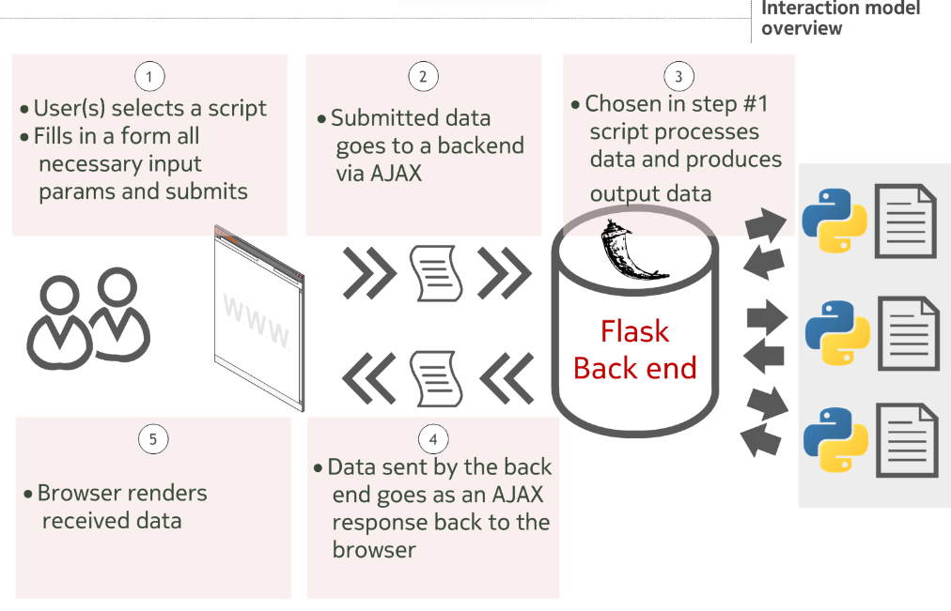

The Flood Prediction System follows a layered architecture consisting of the frontend, backend, machine learning, and deployment layers. Users interact with the system through a web interface developed using HTML, CSS, Bootstrap, and JavaScript. The frontend sends weather parameters to the Flask backend using HTTP requests.
The backend preprocesses the input data using Pandas and NumPy before passing it to the trained machine learning model. Multiple classification algorithms—Decision Tree, Random Forest, K-Nearest Neighbours (KNN), and XGBoost—are evaluated during development, with the best-performing model (XGBoost) saved as a Pickle (.pkl) file and used for prediction.
The prediction result is returned to the Flask application and displayed on the user interface, allowing authorities to quickly assess flood risk. The complete application is designed to be deployed on IBM Cloud, ensuring scalability, accessibility, and reliable operation for disaster management.

